Develop the Python Script

**(Publish data to IBM cloud)**

|  |  |
| --- | --- |
| Date | 19 November 2022 |
| Team ID | PNT2022TMID51070 |
| Project Name | Industry-Specific Intelligent Fire Management System |
| Maximum Marks | 4 Marks |

**Industry-Specific Intelligent Fire Management system**

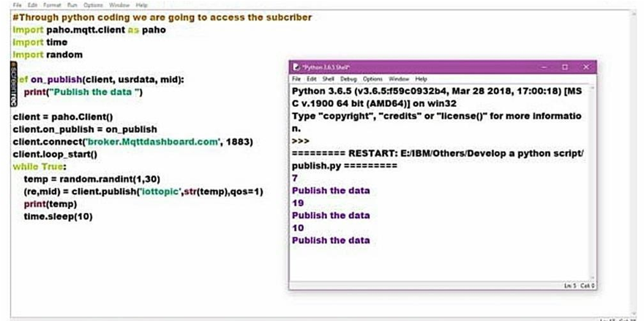

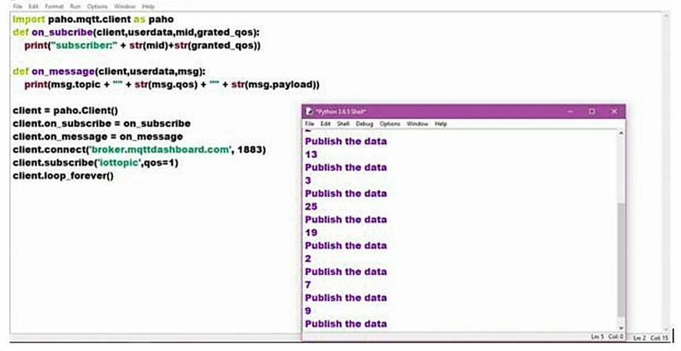

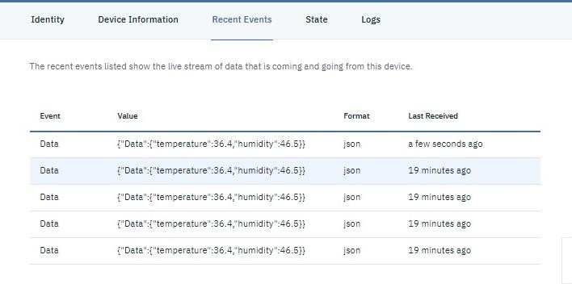

**Program:**

#IBM Watson IOT Platform #pip install wiotp-sdk import wiotp.sdk.device import time

import random myConfig = {"identity":

{

"orgId": "88653s",

"typeId": "123", "deviceId":"ggg"},

"auth": {"token": ")1(uiYYO)Nmkr9sk(k"}

}

def myCommandCallback(cmd):

print("Message received from IBM IoT Platform: %s" % cmd.data['command']) m=cmd.data['command']

client = wiotp.sdk.device.DeviceClient(config=myConfig, logHandlers=None) client.connect()

while True: temp=random.randint(-20,125) hum=random.randint(0,100)

myData={'temperature':temp, 'humidity':hum} client.publishEvent(eventId="status", msgFormat="json", data=myData, qos=0,

onPublish=None)

print("Published data Successfully: %s", myData) client.commandCallback = myCommandCallback time.sleep(2)

client.disconnect()